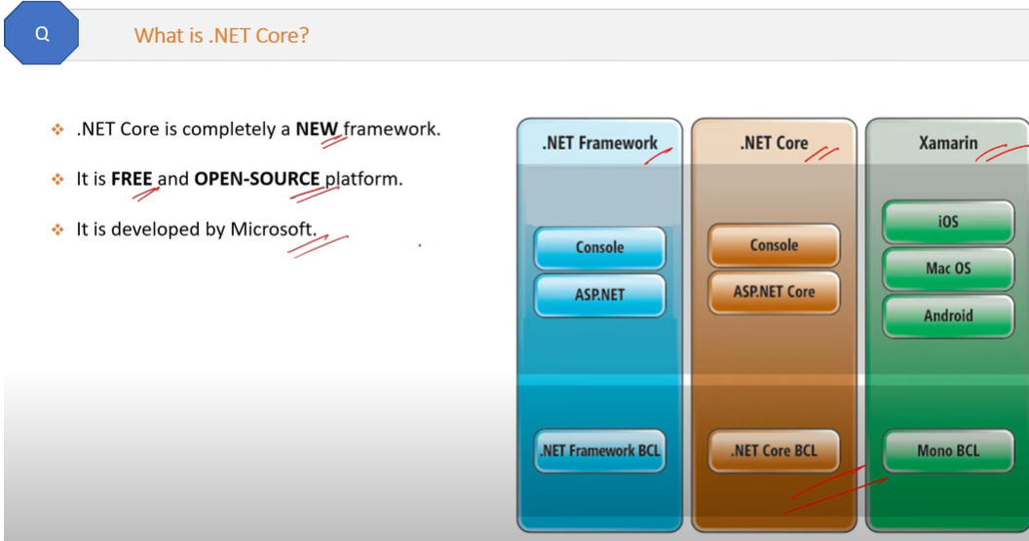

* Open-source means, it works in windows and Linux OS.
* .Net framework is paid but .net core is free.

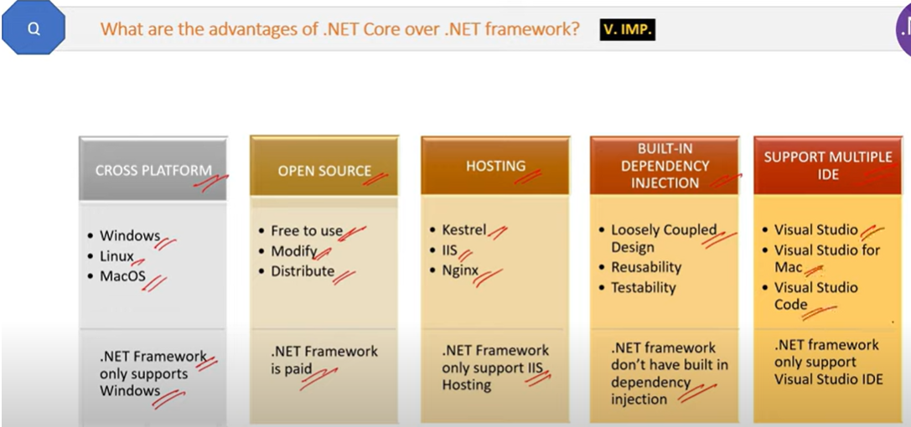

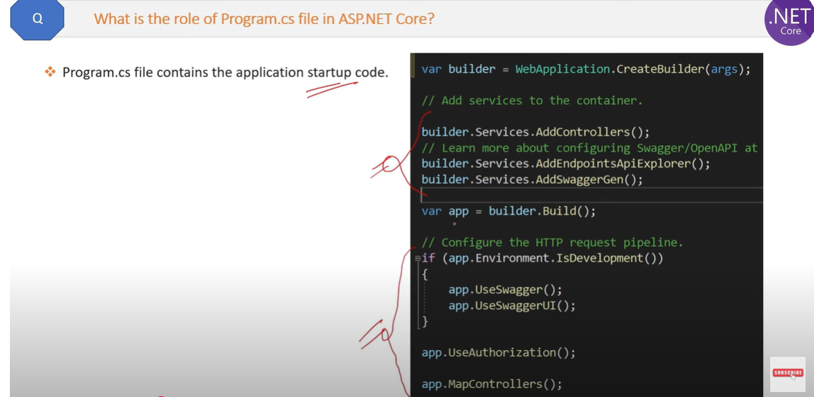

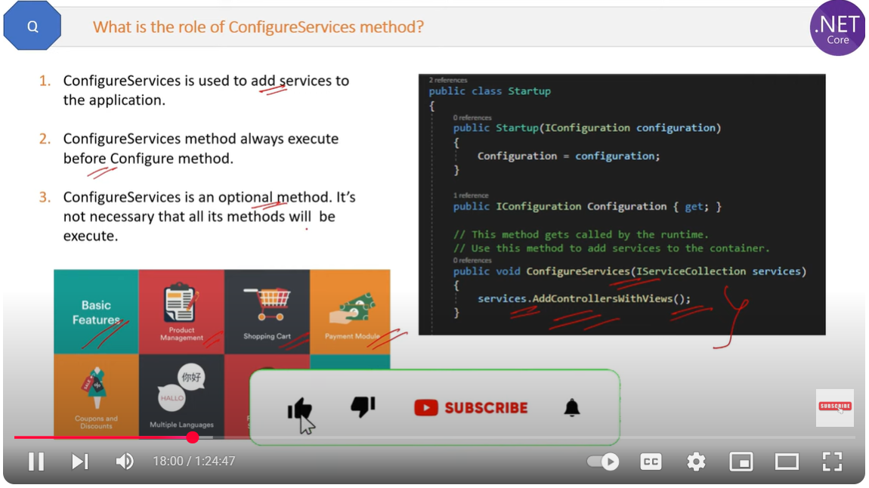

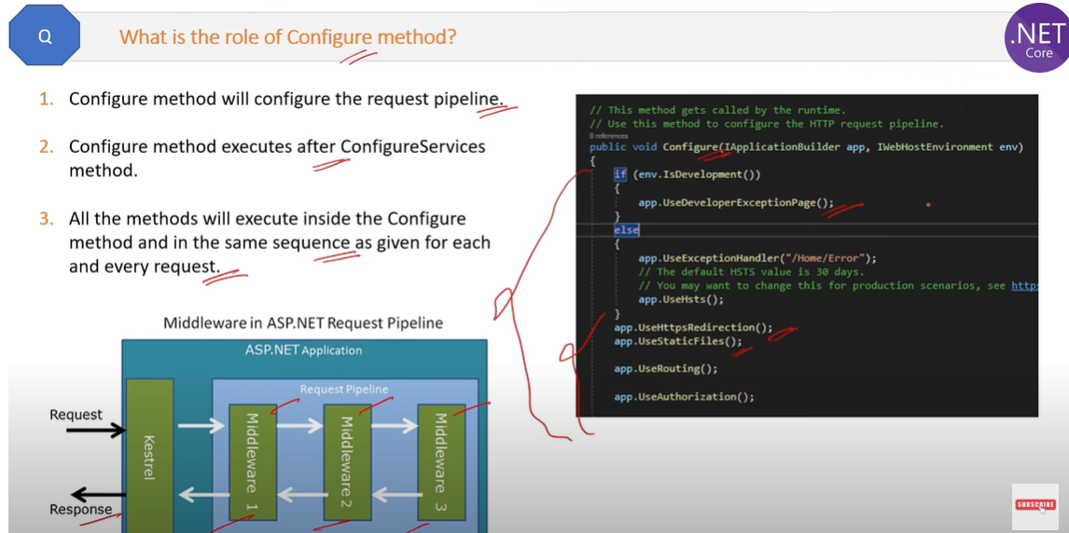

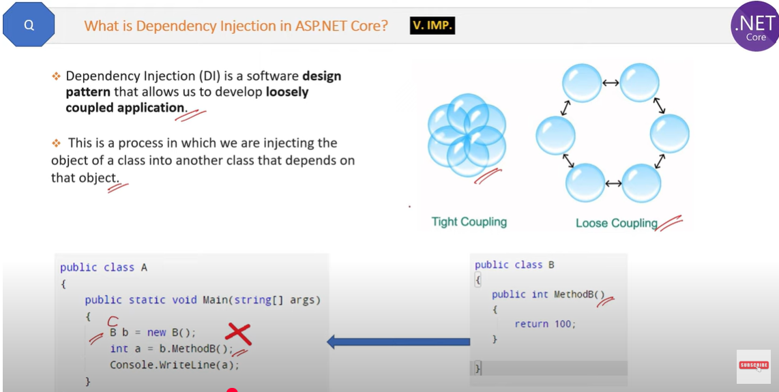

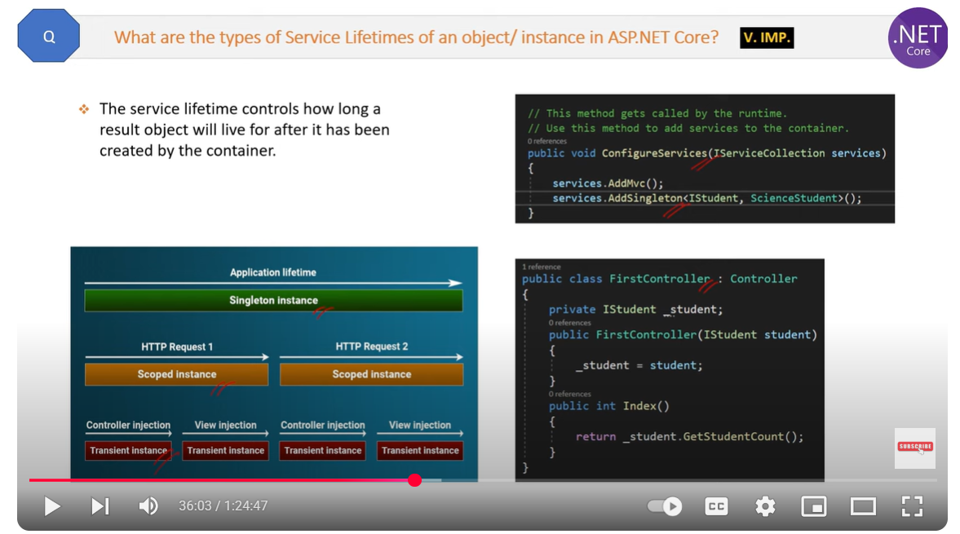

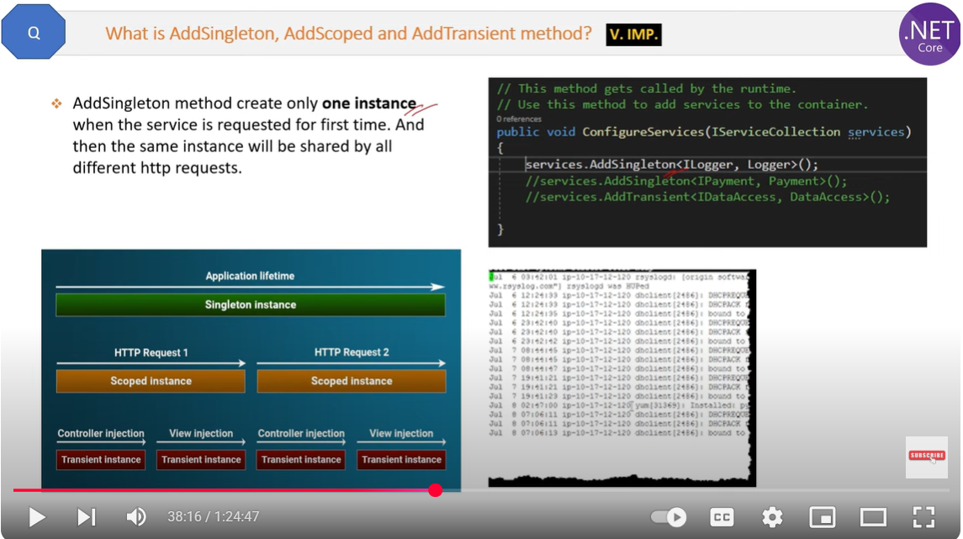

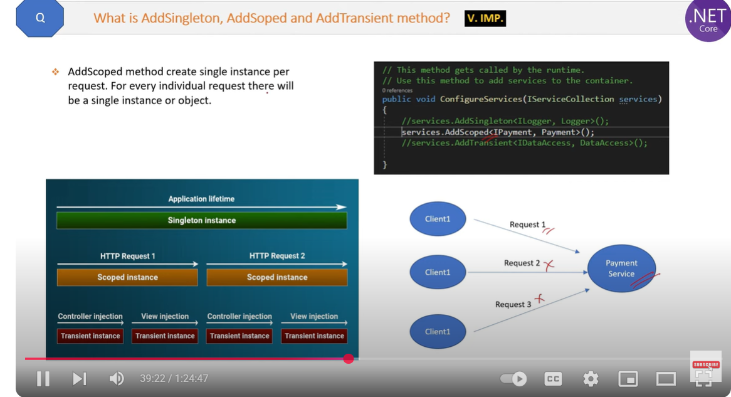

**AddScoped**:

* An instance of the service is created once per scope.
* A new instance is created for each new scope (e.g., each new HTTP request). Within that scope, the same instance is reused for all subsequent requests for that service.

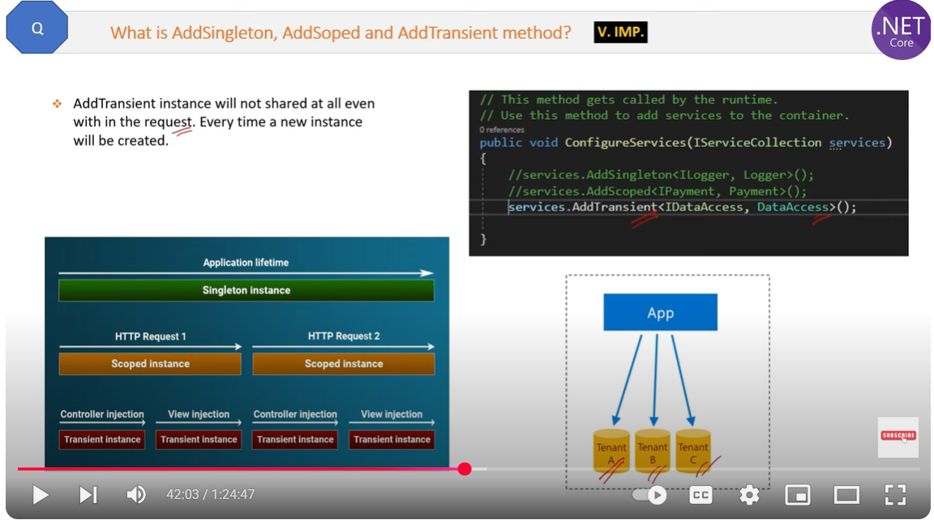

**AddTransient**:

* A new instance of the service is created every time it is requested.

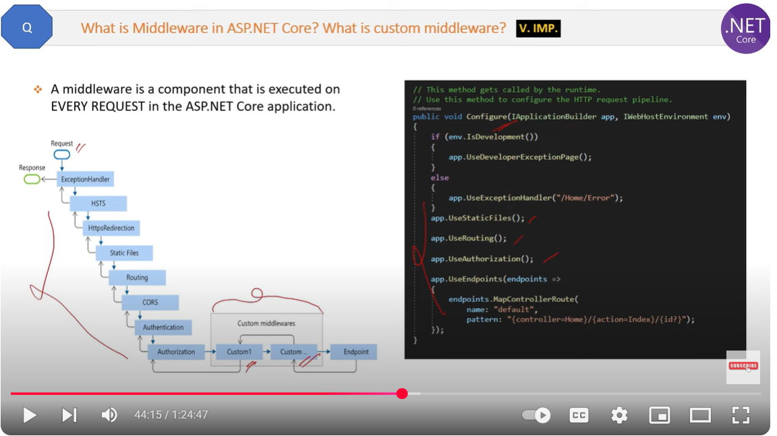

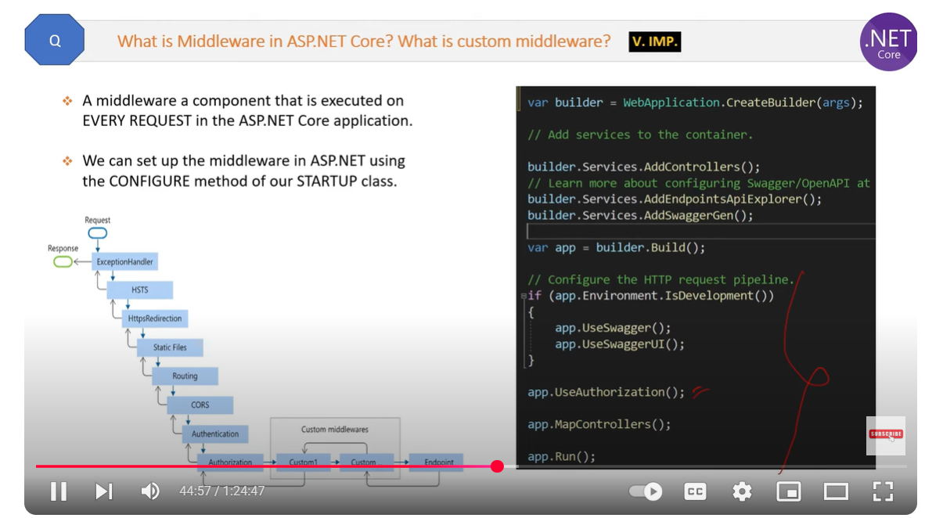

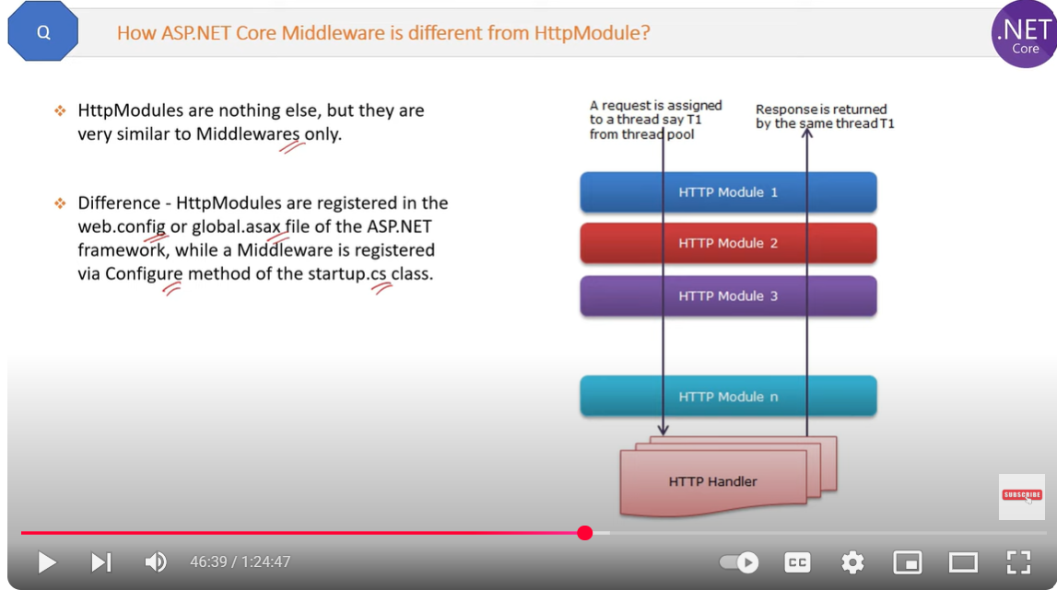

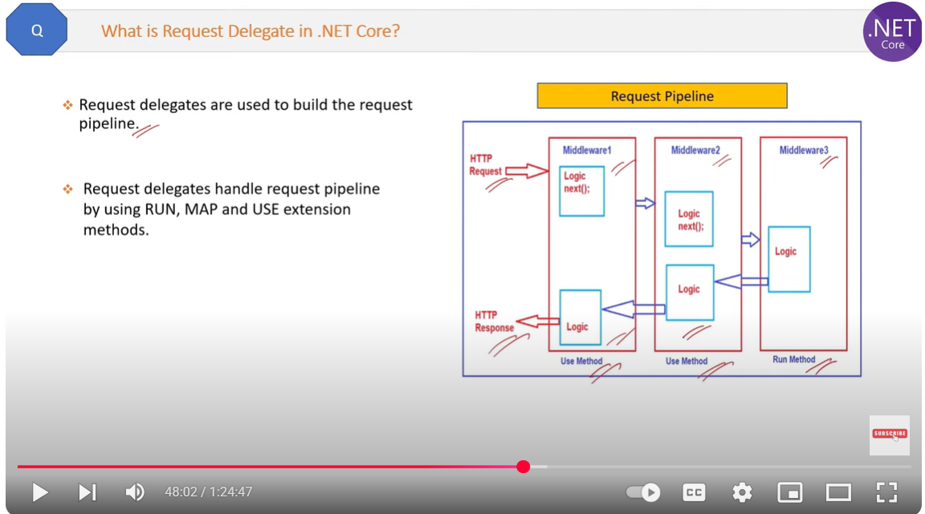

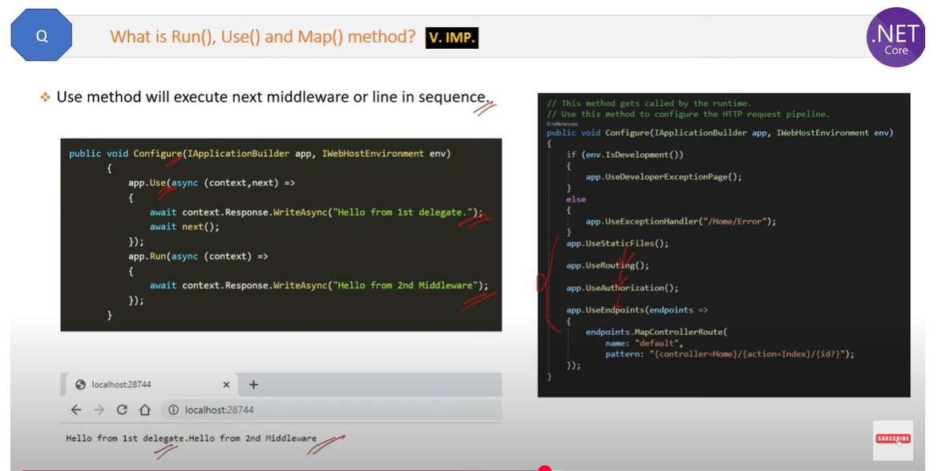

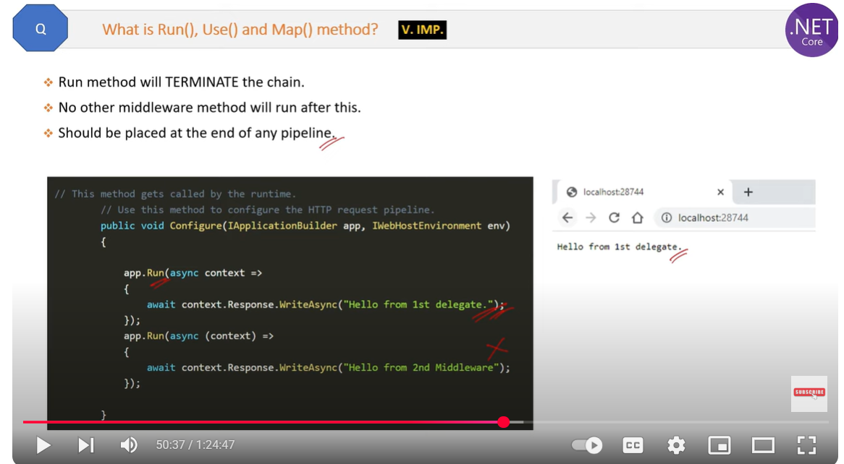

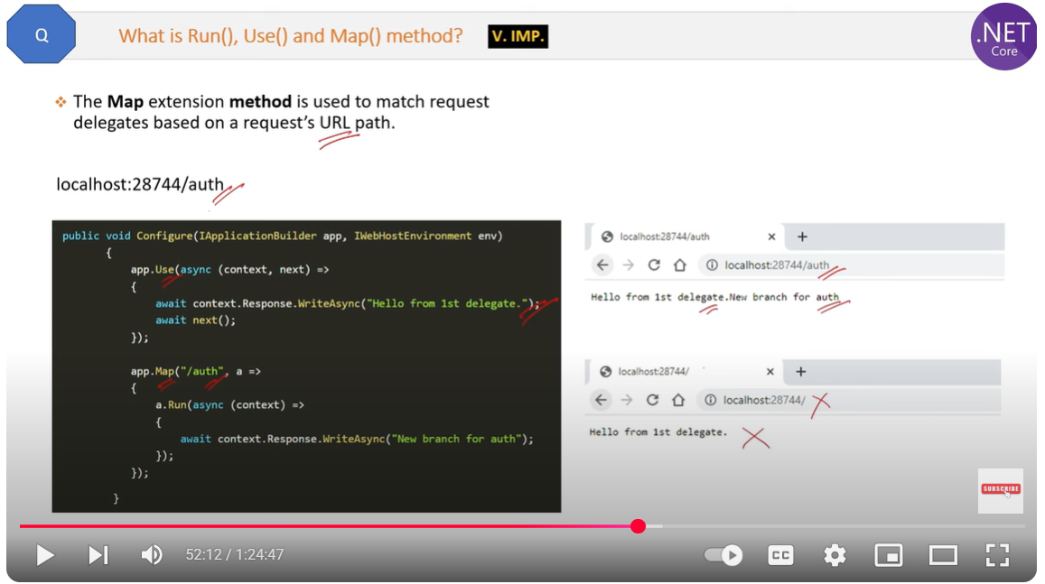

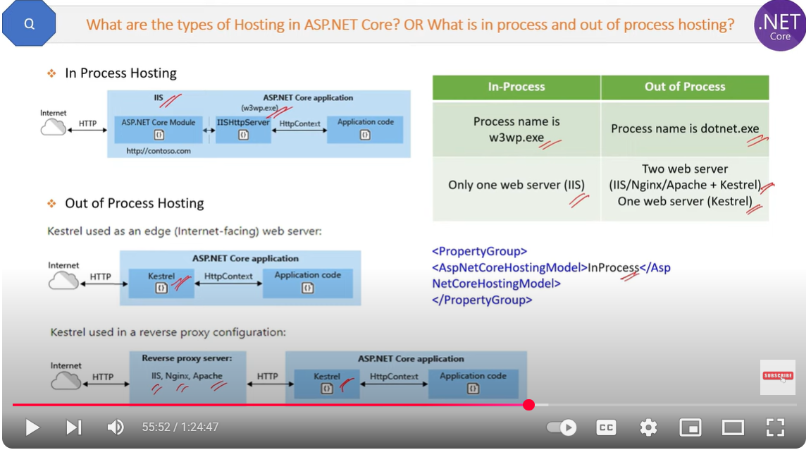

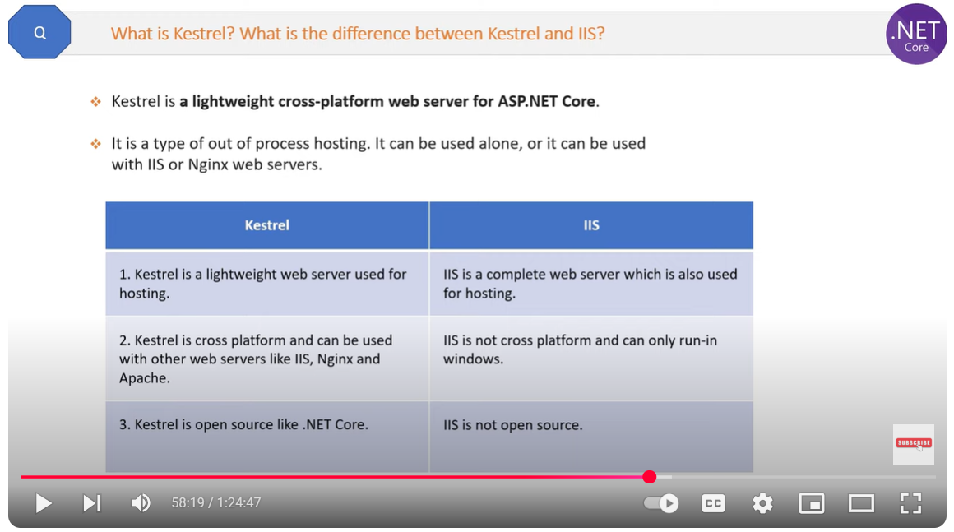

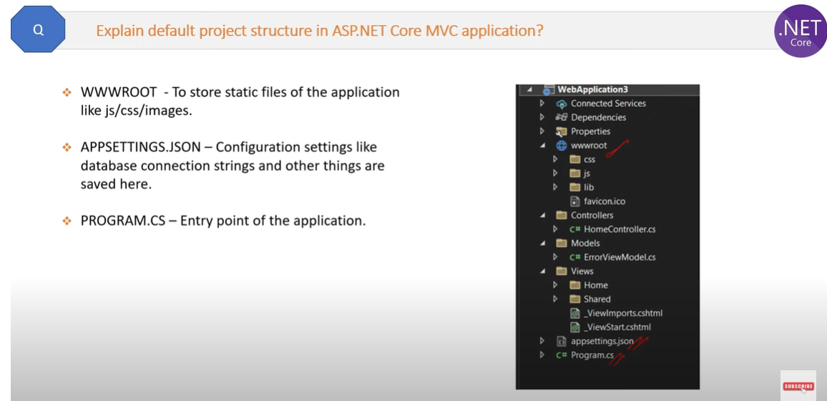

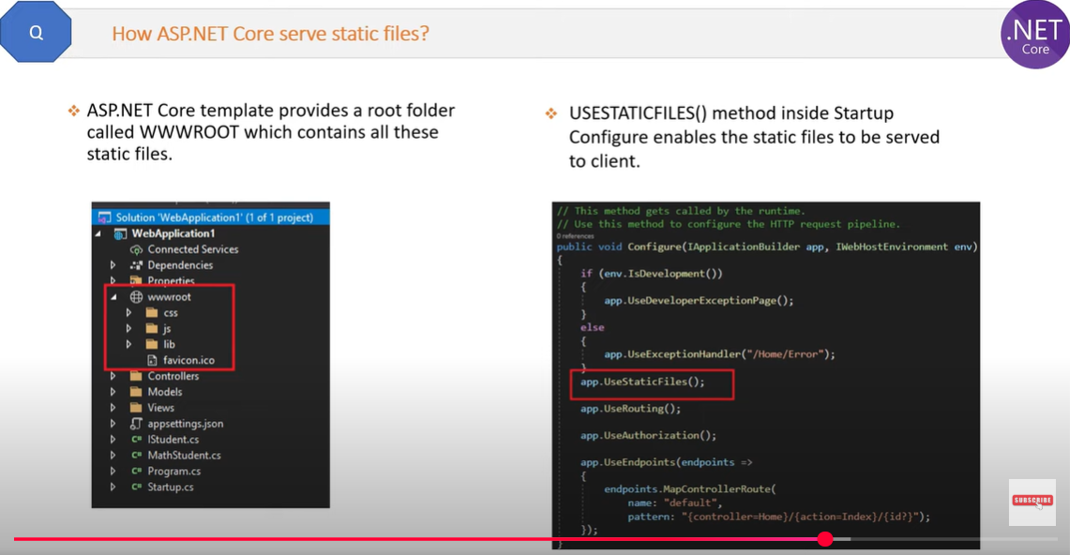

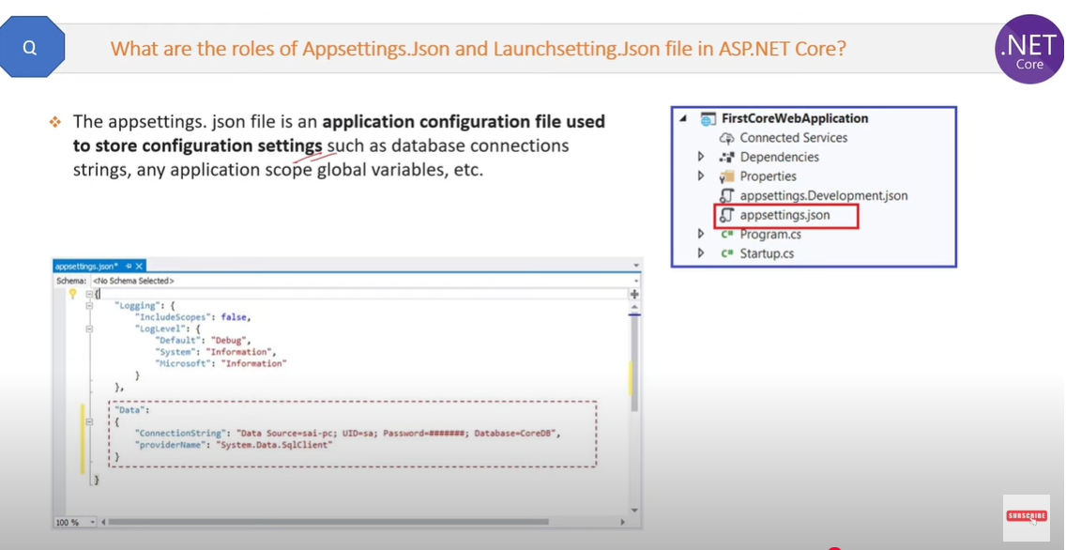



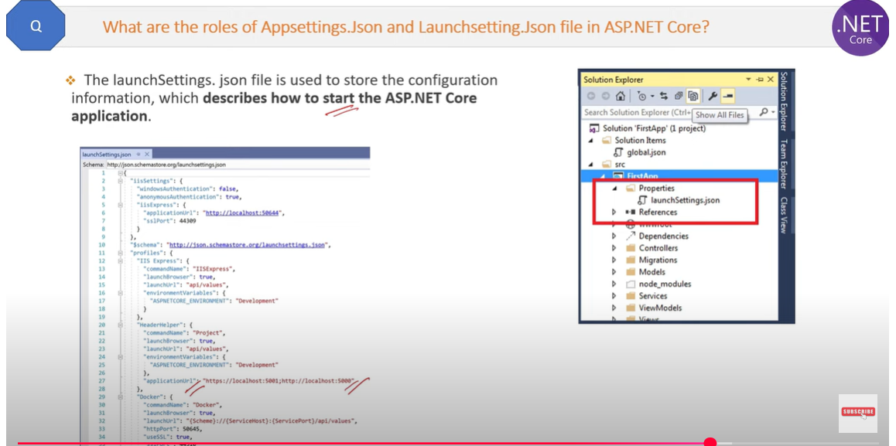

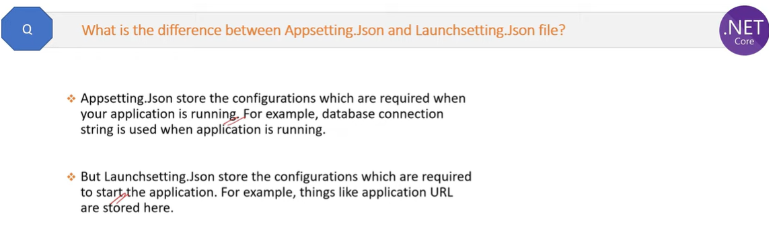

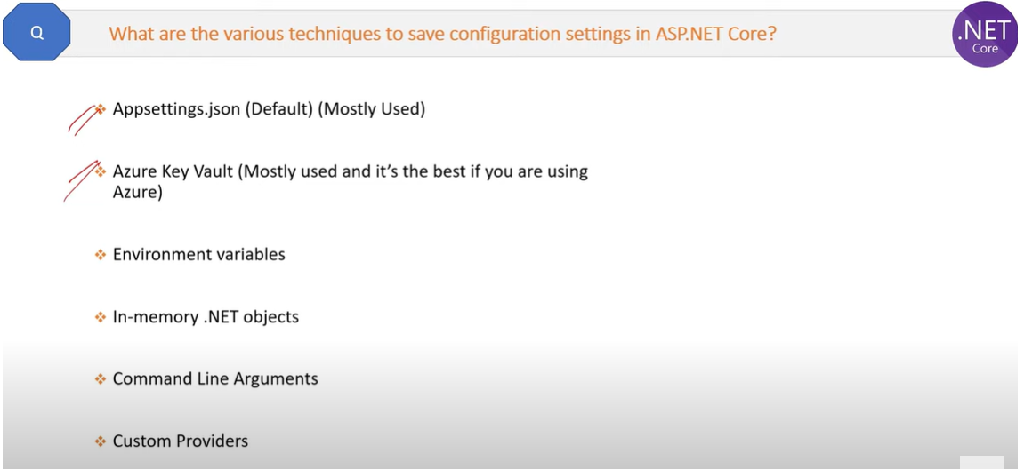

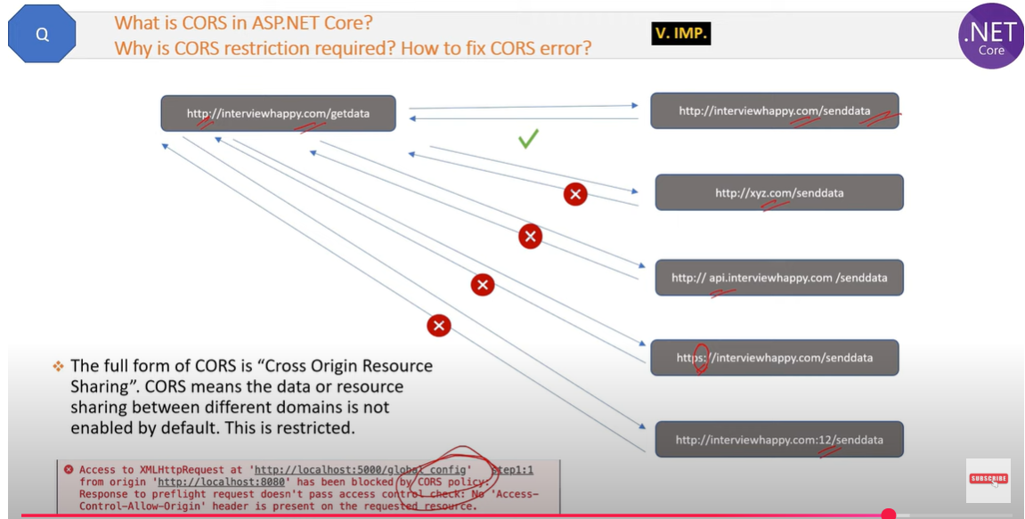

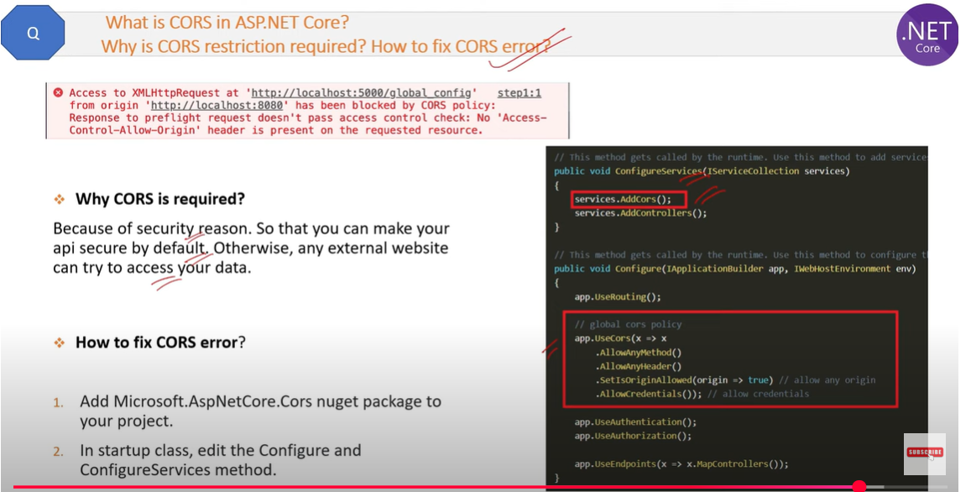

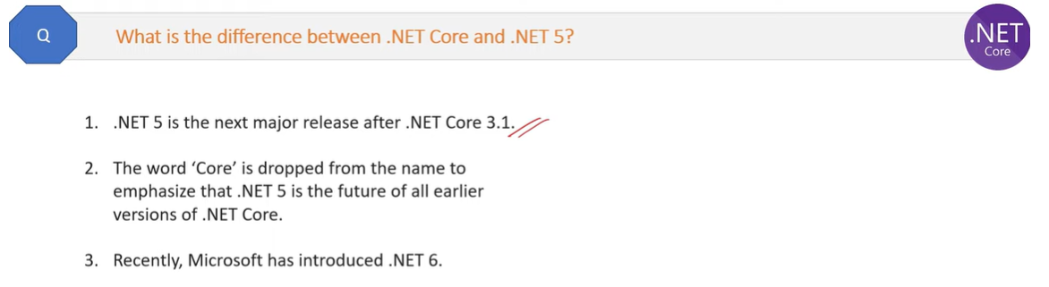

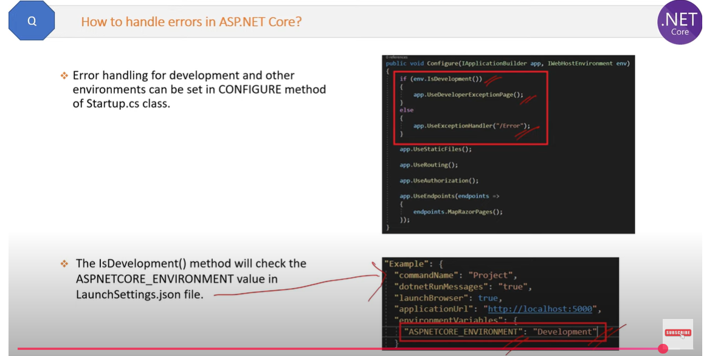

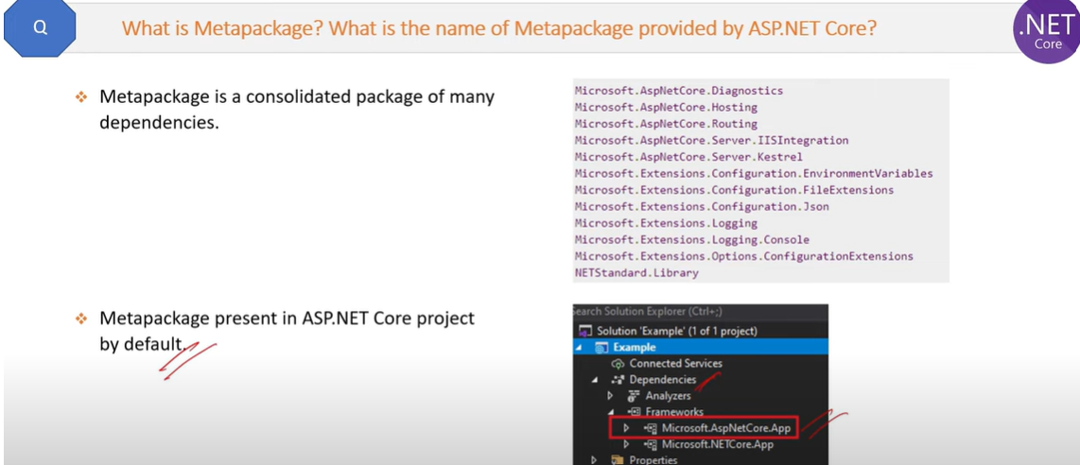

**What is Rate limiting in .net core?**

* If you want to limit consuming the API for a particular client within a certain time, then you can achieve it by ***Rate Limiting***.
* Rate Limiting is the process of ***controlling the number of requests for a resource within a specific time window***. Each unique user/IP address/client will have a limitation on the number of requests to an API endpoint.
* Why do we need Rate Limiting?

1. Rate Limiting helps us to protect against malicious bot attacks.
2. For example, a hacker can use bots to make repeated requests to an API endpoint. Due to the number of repeated requests, resulting in will be service unavailable for others. This is called as the Denial of Service (DoS) attack. So, the rate limiting helps us from the DoS attack.

* We can implement the rate limiting using below ways,

1. Using a Custom Middleware
2. Using the AspNetCoreRateLimit NuGet Package

* To configure the rate limiting to use in-memory persistence, add the following lines to the ***ConfigureServices()*** method in ***Startup***class.

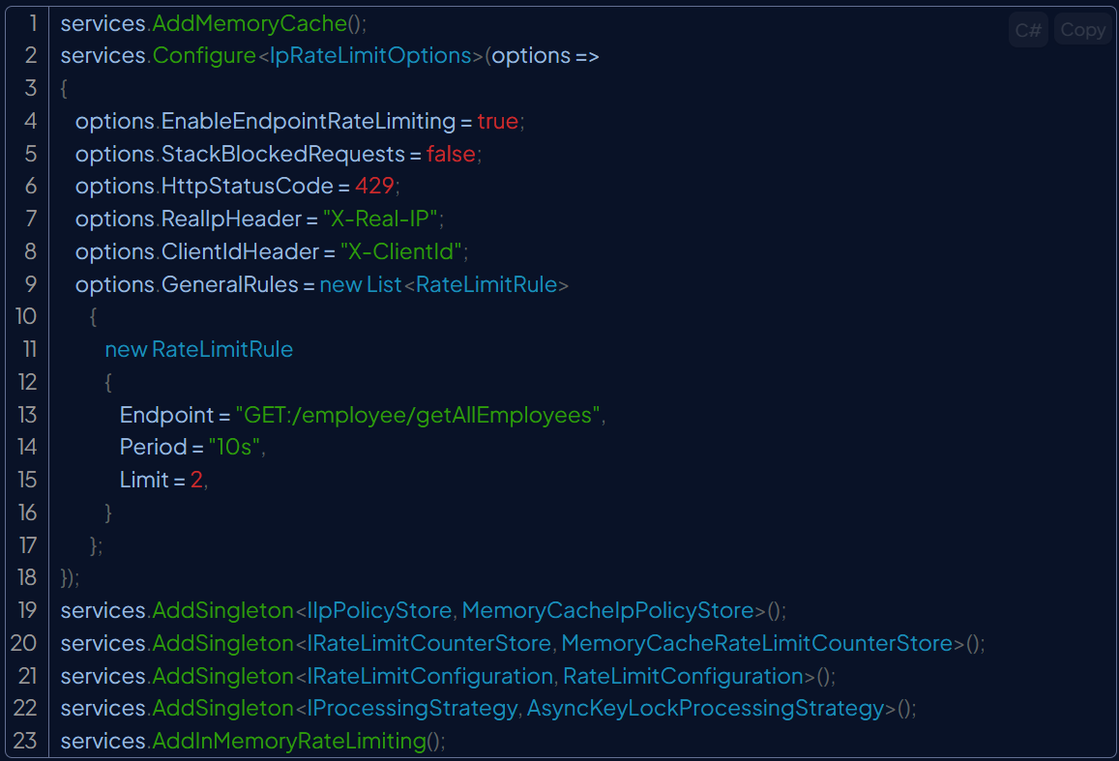

Add the following lines to the ***Configure()*** method in ***Startup***class.



In the above code, the option ***EnableEndpointRateLimiting***is set as true to ensure that limit is applied to specific endpoints (here ***employee/getAllEmployees***) rather than all endpoints. If EnableEndpointRateLimiting is set to false then the limits will apply globally and only rules that have as endpoint* will apply.

The **RealIpHeader** is used to extract the client IP.

The **ClientIdHeader** is used to extract the client id for whitelisting.

The rate limiting rules are set in the GeneralRules section.

In the above example, the rule specifies that for the endpoint /employee/getAllEmployees with an HTTP verb GET, allow only 2 requests in a time window of 10 seconds.

Endpoint format is ***{HTTP_Verb}:{PATH}***, you can target any HTTP verb by using the Asterix (*) symbol.

Period format is ***{INT}{PERIOD_TYPE}***, you can use one of the following period types: s, m, h, d.

Limit format is ***{LONG}***.

Execute the **getAllEmployees**endpoint. You will get below response. The API endpoint returns result along with three response headers, related to rate-limiting.

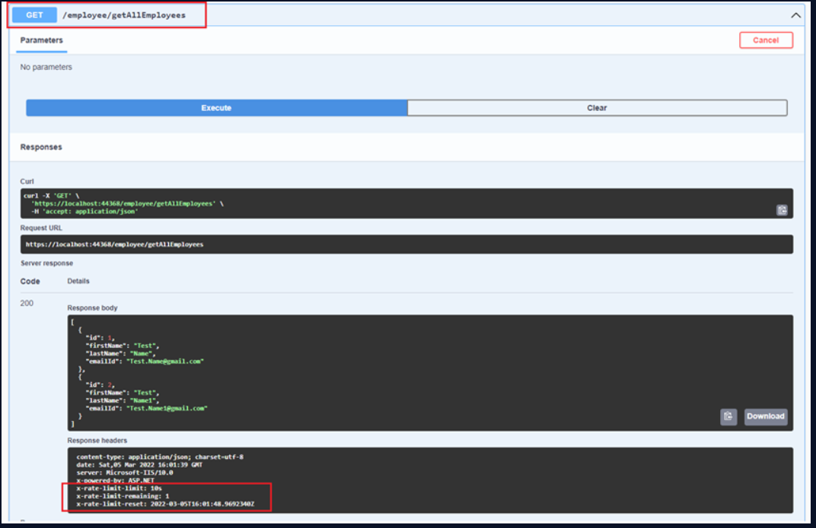

* **x-rate-limit-limit** - It shows the rate limit time window
* **x-rate-limit-remaining** - The remaining number of requests for the API endpoint for that particular time window.
* **x-rate-limit-reset** - It displays the time stamp for resetting the limit rules.

If you hit the above endpoint more than 2 times within 10 seconds (rate-limiting rules are violated) then failure response (status code is 429) will be returned. The headers has ***retry-after: 7*** which means the client to retry after 7 seconds to avoid the violation of rate-limiting rules.

**Web API HTTP codes**

In [ASP.NET](https://dotnet.microsoft.com/en-us/apps/aspnet) Core Web API, HTTP status codes are used to indicate the outcome of a client's request to the server. These codes are categorized into five classes:

1xx Informational: The request was received and the process is continuing.

* 100 Continue: The client should continue with the request.
* 101 Switching Protocols: The server is switching protocols as requested by the client.

2xx Success: The request was successfully received, understood, and accepted.

* 200 OK: The request succeeded.
* 201 Created: The request succeeded, and a new resource was created.
* 202 Accepted: The request has been accepted for processing, but the processing is not yet complete.
* 204 No Content: The server successfully processed the request, but is not returning any content.

3xx Redirection: Further action needs to be taken to complete the request.

* 301 Moved Permanently: The requested resource has been permanently moved to a new URL.
* 302 Found: The requested resource is temporarily located at a different URL.
* 304 Not Modified: The client's cached copy of the resource is still valid.

4xx Client Error: The request contains bad syntax or cannot be fulfilled.

* 400 Bad Request: The server could not understand the request due to invalid syntax.
* 401 Unauthorized: The request requires user authentication.
* 403 Forbidden: The client does not have access rights to the content.
* 404 Not Found: The server cannot find the requested resource.
* 405 Method Not Allowed: The HTTP method used in the request is not supported for the requested resource.
* 409 Conflict: The request could not be completed due to a conflict with the current state of the resource.
* 429 Too Many Requests: The user has sent too many requests in a given amount of time.

5xx Server Error: The server failed to fulfill an apparently valid request.

1. 500 Internal Server Error: The server encountered an unexpected condition that prevented it from fulfilling the request.
2. 501 Not Implemented: The server does not support the functionality required to fulfill the request.
3. 502 Bad Gateway: The server, while acting as a gateway or proxy, received an invalid response from an upstream server.
4. 503 Service Unavailable: The server is currently unable to handle the request due to temporary overload or maintenance.
5. What are the key differences between **.NET 6/7** and previous versions of **.NET Core**?

**.NET 6**

* **Type:** Long-Term Support (LTS) version
* **Cross-Platform Unified Platform:** Works the same on Windows, Linux, macOS, iOS, and Android.
* **Blazor Improvements:** Build interactive web apps with C# instead of JavaScript.
* **Hot Reload:** Make changes in code and see results instantly without restarting the app.
* **Minimal APIs:** Simplified way to create lightweight microservices and web APIs.
* **C# 10 Support:** New language features to make coding easier.

**.NET 7**

* **Type**: Current release (short-term support, until May 2024).
* **Performance Focus**: Faster execution, lower memory usage.
* **Cloud-Native Enhancements:** Better for microservices and distributed systems.
* **Native AOT (Ahead-of-Time Compilation**): Makes applications smaller and faster by compiling them directly into native code.
* **C# 11 Support**: New features for developers to write cleaner and more powerful code.
* .NET 7 pushed performance and cloud support, but since it’s not LTS

NET 6 and 7 bring **massive speed gains** compared to .NET Core 3.x / 5.

1. What are **ValueTask** and **IAsyncEnumerable** in .NET? When would you prefer using them?

* ValueTask is a **lightweight alternative** to Task, introduced to **reduce memory allocations** in high-performance asynchronous code.
* using Task can cause **unnecessary heap allocations** — since each completed Task still creates an object.
* ValueTask helps avoid that by allowing the result to be returned directly (on the stack) if the operation is already done.

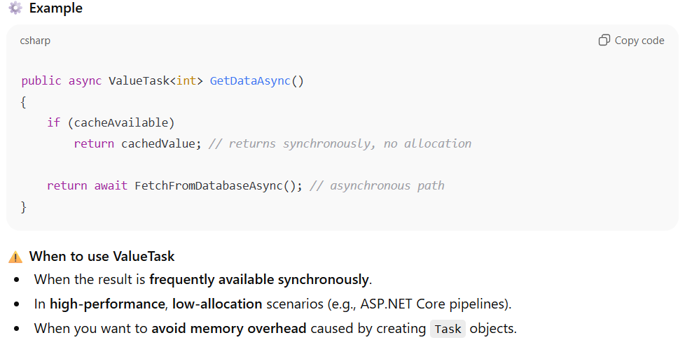

**IAsyncEnumerable in .NET**

* IAsyncEnumerable<T> represents an **asynchronous data stream** (introduced in .NET Core 3.0 / C# 8).
* It allows you to **iterate over asynchronous sequences** — e.g., fetching data piece by piece without blocking threads.

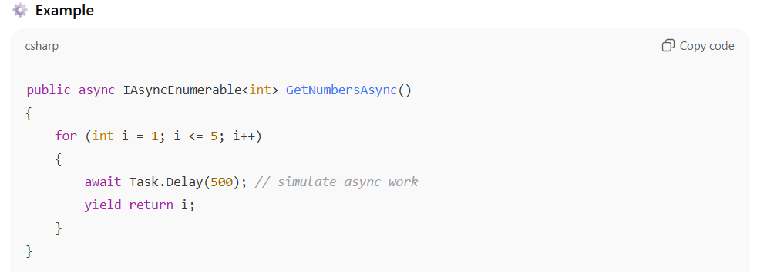

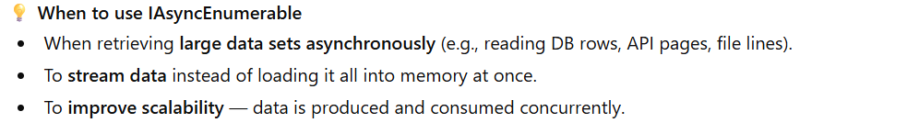

1. Explain how you would design and expose a **RESTful API** in .NET Core with proper versioning and security.

* **Versioning in ASP.NET Core :** Existing Web API can be consumed by many clients so how to implement the new feature without impacting the existing consumers? We can solve this problem by versioning our API.
* **Different ways of Versioning Web API:** We can do versioning of Web API using the following methods:
* **Query string**
* **URL**
* **HTTP header**
* Manage Nuget Package and search for package "Microsoft.AspNetCore.Mvc.Versioning" and install it.

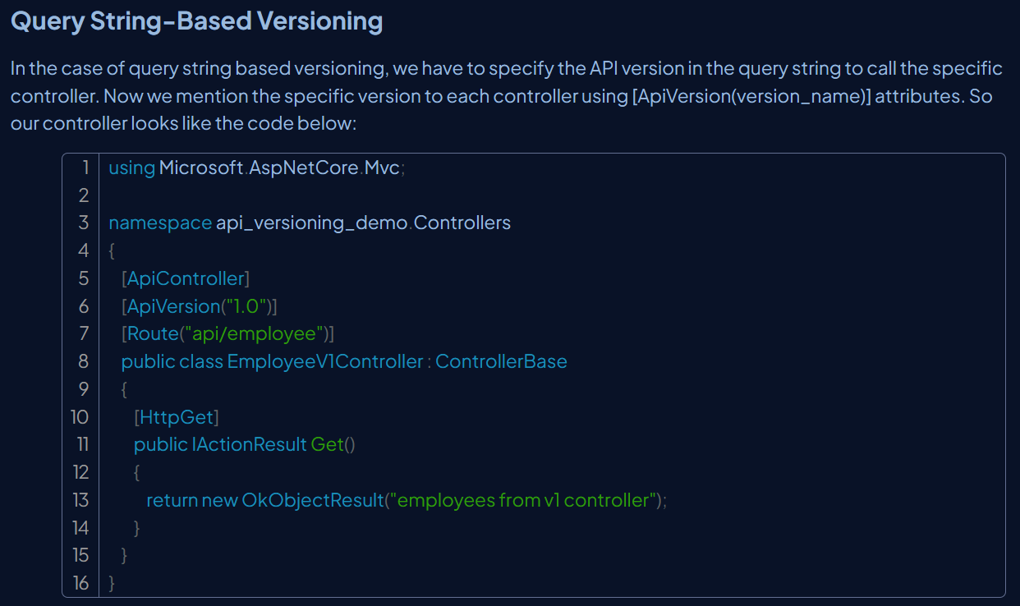

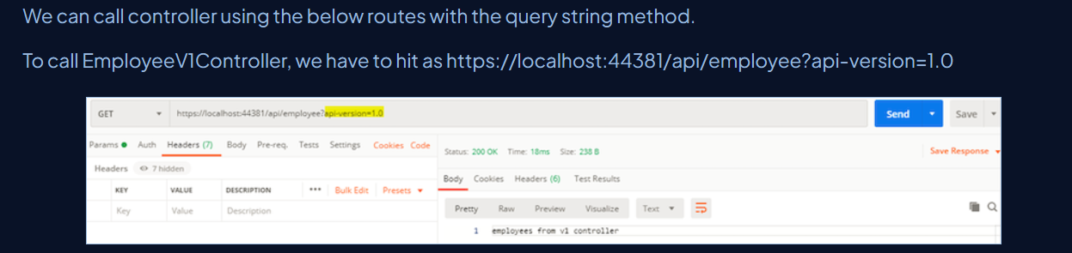

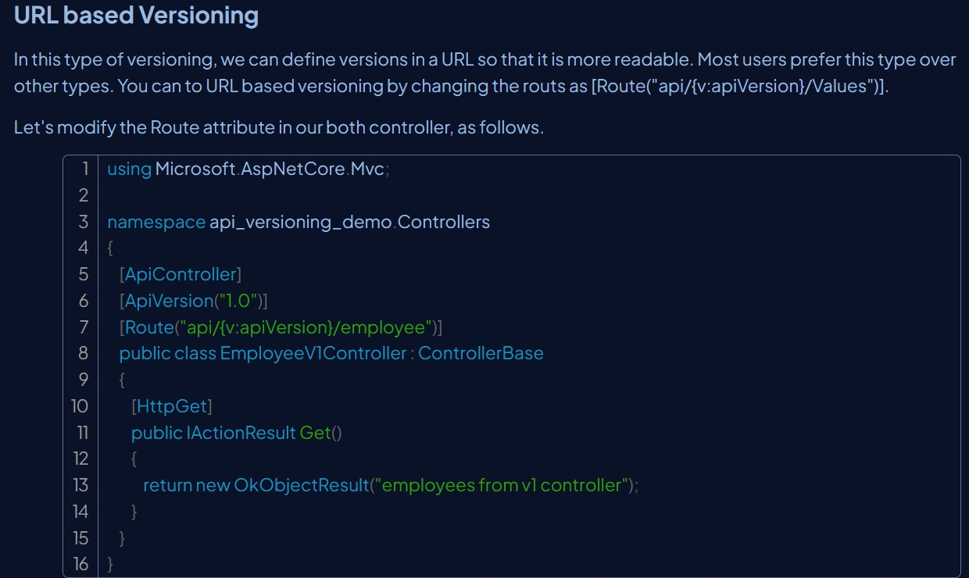

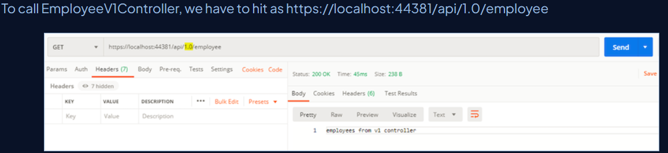

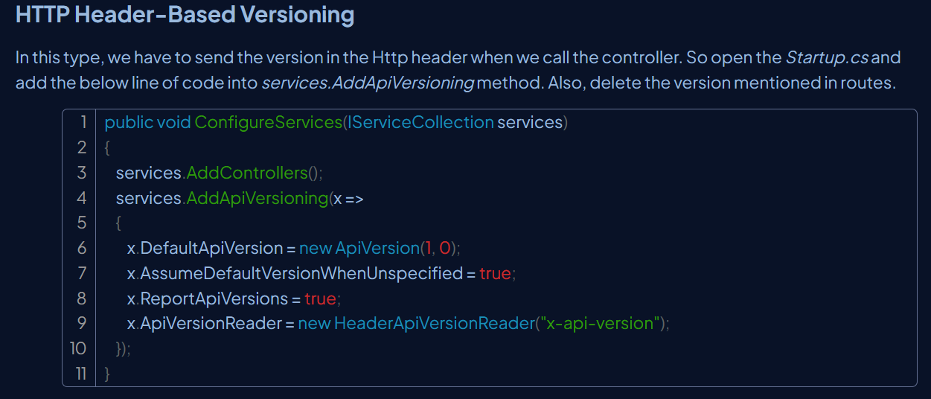

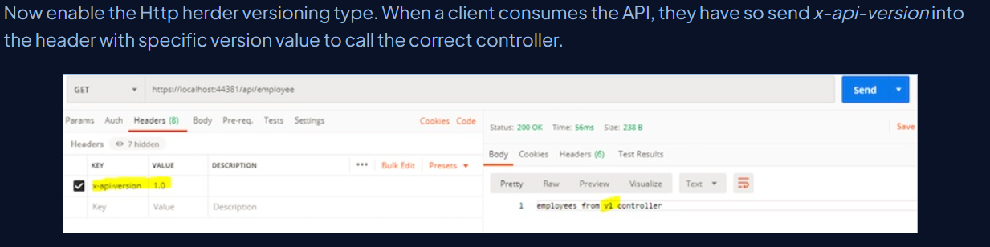

**JWT Tokens for securing web API:** JWT stands for JSON Web Token digitally signed using a secret key by a token provider. It helps the resource server to verify the token data using the same secret key.

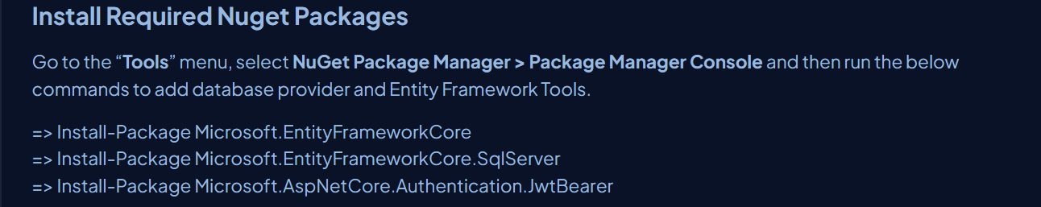

**Adding the Token to the Application**

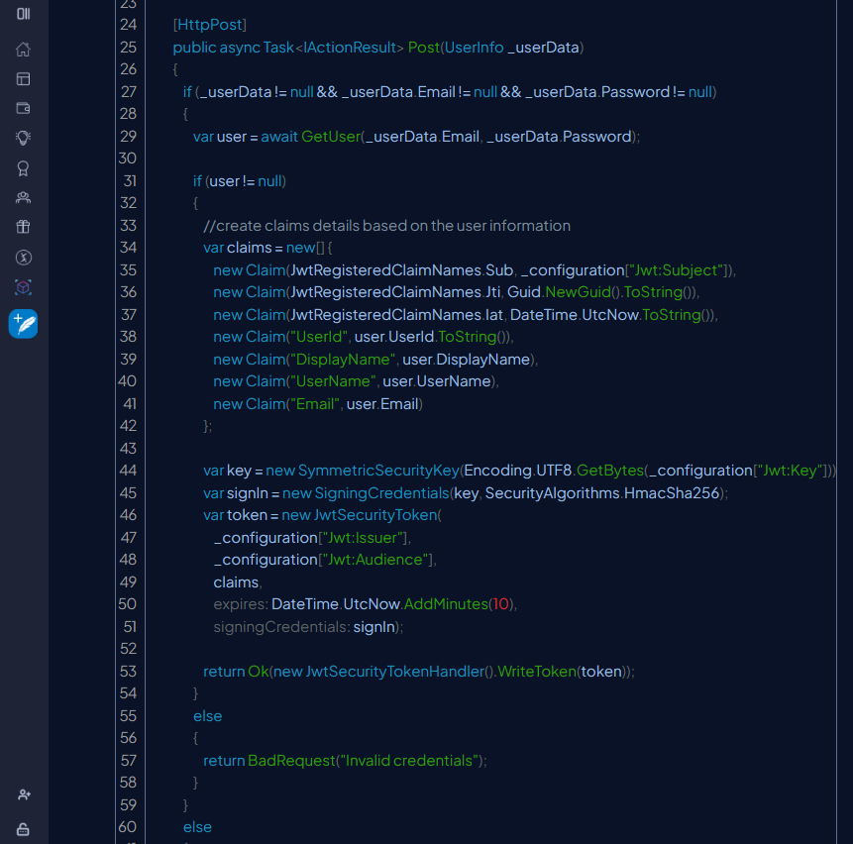

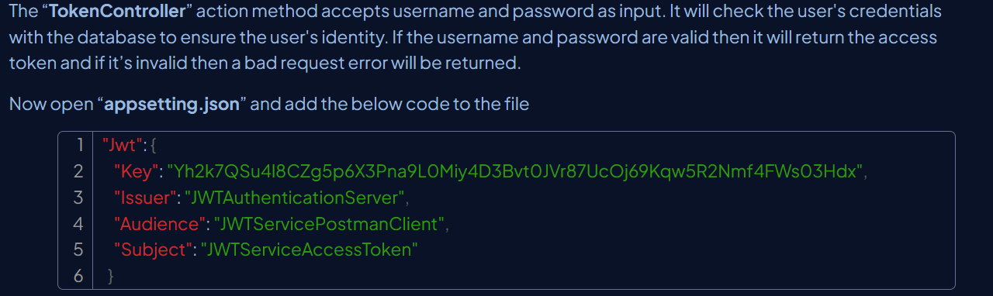

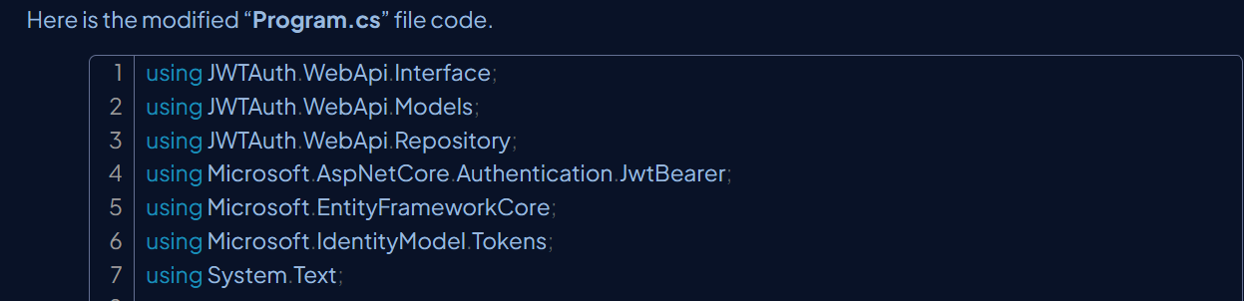

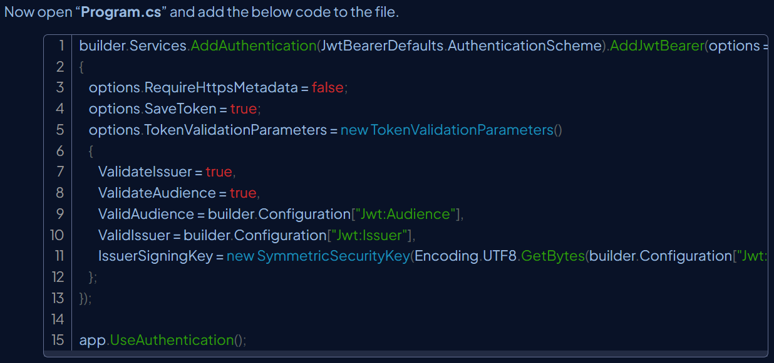

In the above code, we configured authorization middleware in the startup. Here we have passed the security key when creating the token and enabled validation of Issuer and Audience. Also, we have set “**SaveToken**” to true, which stores the bearer token in HTTP Context. So we can use the token later in the controller.

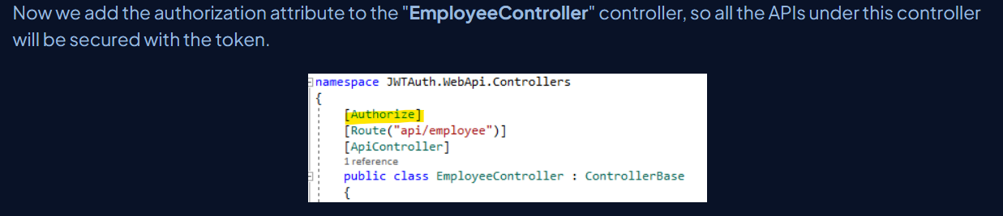

8. What’s the difference between **Task.Run()** and **async/await**? When should each be used?

* **Task.Run()** and **async/await** are both mechanisms for asynchronous programming in C#, but they serve different primary purposes

**Task.Run()**

* **Purpose:**  Task.Run() is used to execute synchronous, CPU-bound work on a background thread from the ThreadPool. This prevents the main thread (e.g., the UI thread in a desktop application) from being blocked, ensuring responsiveness.
* **When to use:**  When you have a piece of code that performs intensive calculations or other operations that consume significant CPU time, and you need to offload it from the current thread to prevent blocking.

**async/await**

* **Purpose:**  async/await is used to simplify asynchronous, I/O-bound operations. It allows your code to pause execution while waiting for an external resource (like a network request, database query, or file access) without blocking the current thread.
* **When to use:**  When you are performing operations that involve waiting for external resources, and you want to keep your application responsive during these waiting periods.

How do you implement **caching** (in-memory, distributed, or Redis) in a .NET Core application?

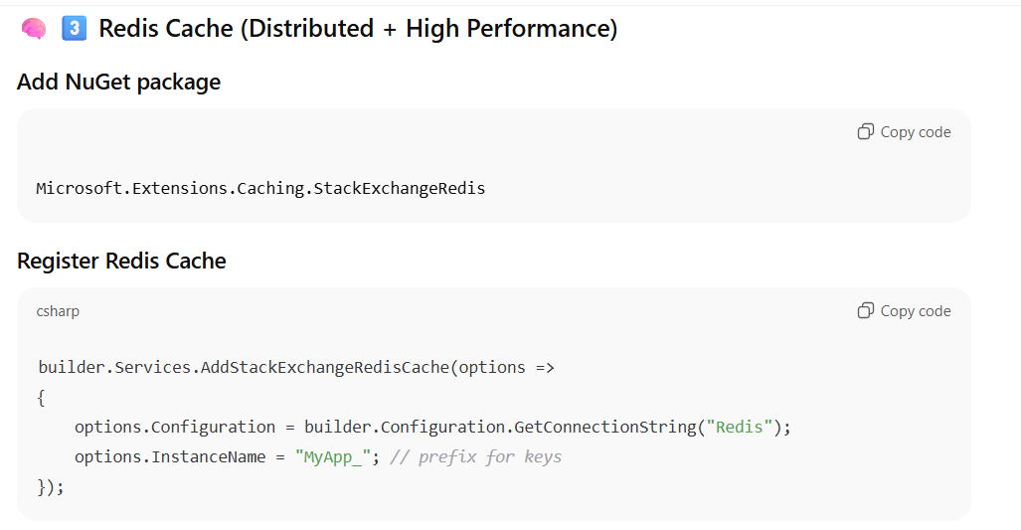

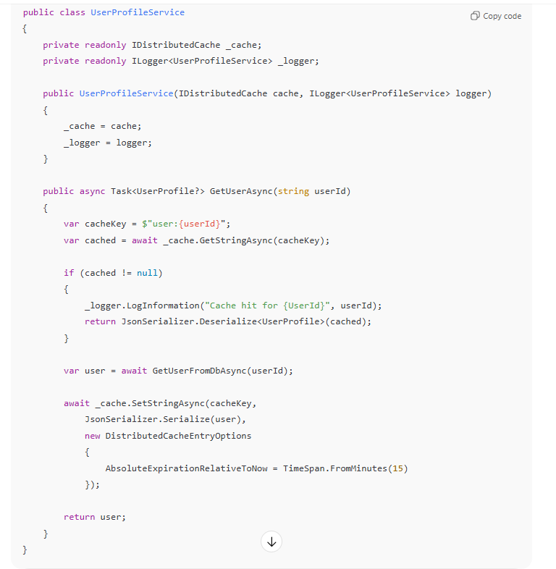

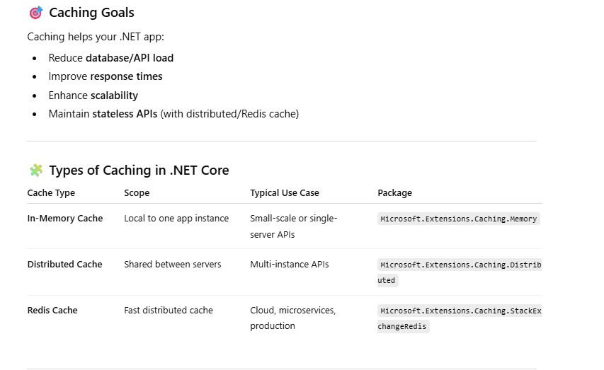

Can you explain how **Entity Framework Core** handles **change tracking** and what strategies improve performance?

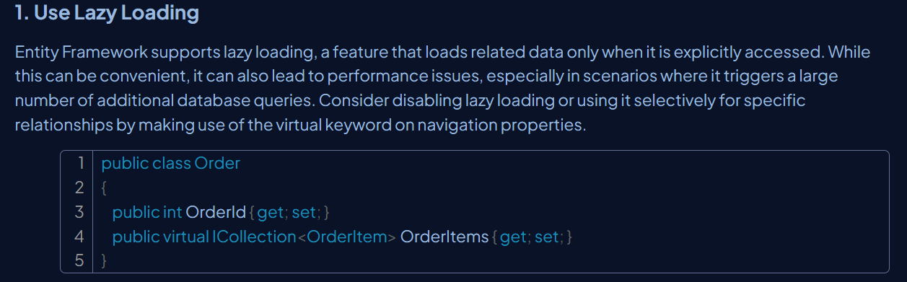

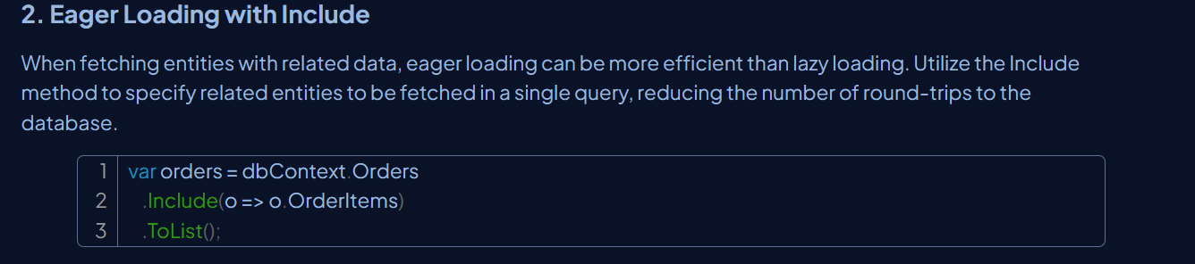

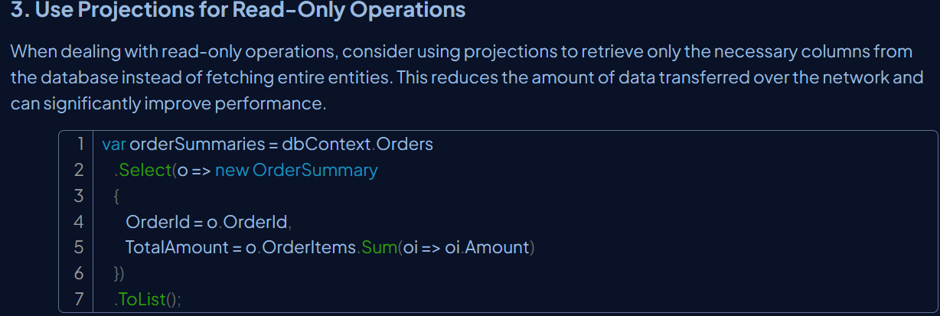

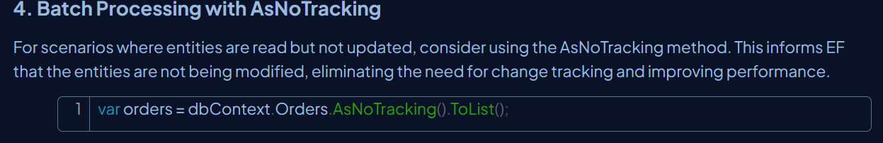

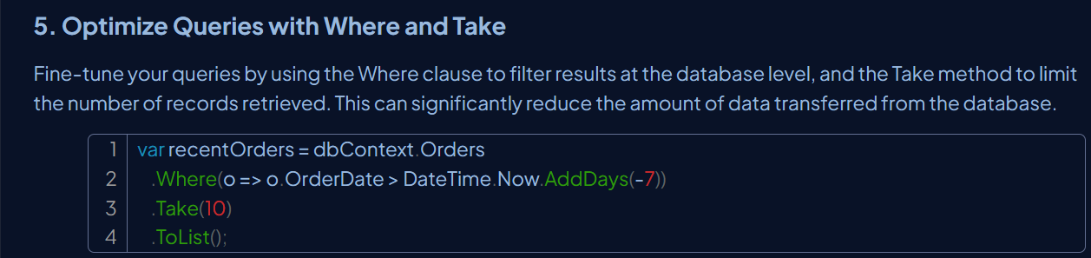

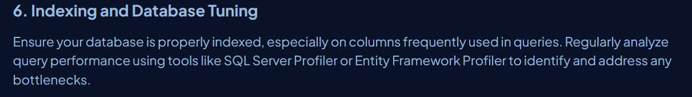

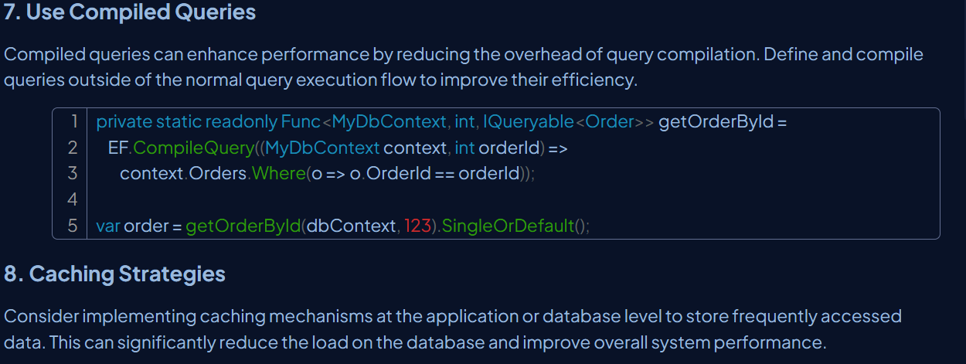

How do you approach **performance optimization** in a .NET application—both in code and database access?

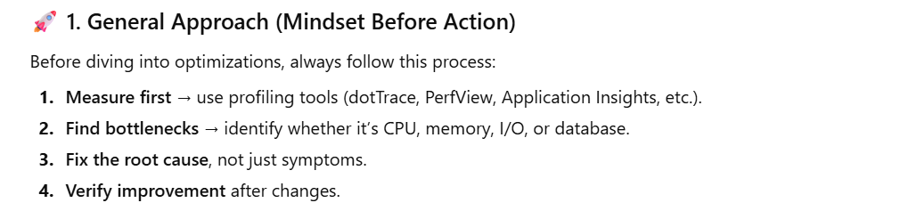

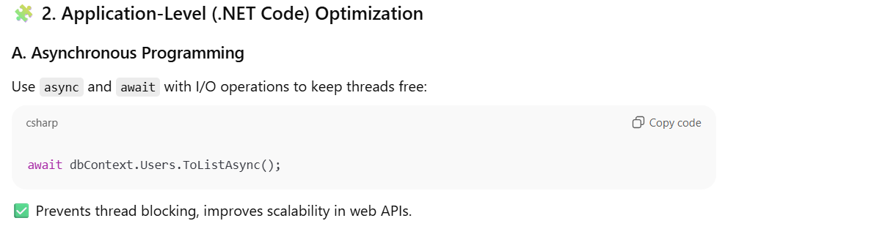

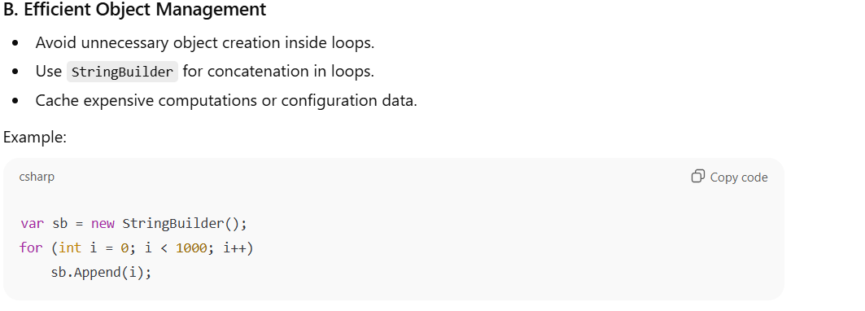

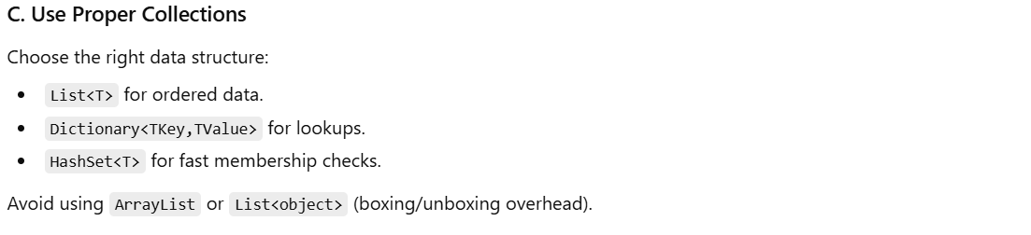

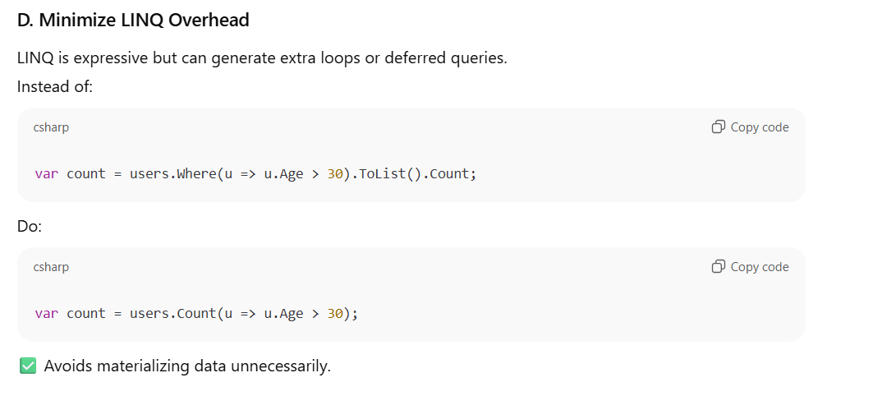

**Difference Between Dictionary And Hashtable In C#**

Dictionary and Hashtable in C# are used to hold data as a collection of key-value pair.

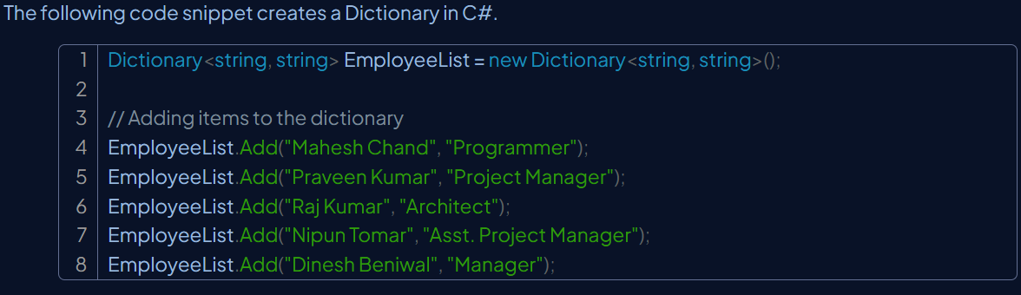

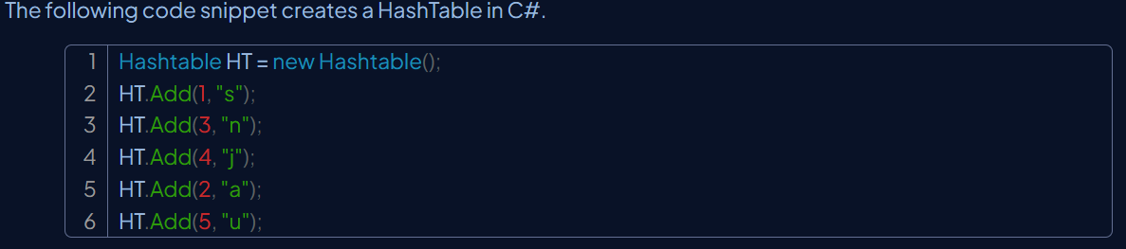

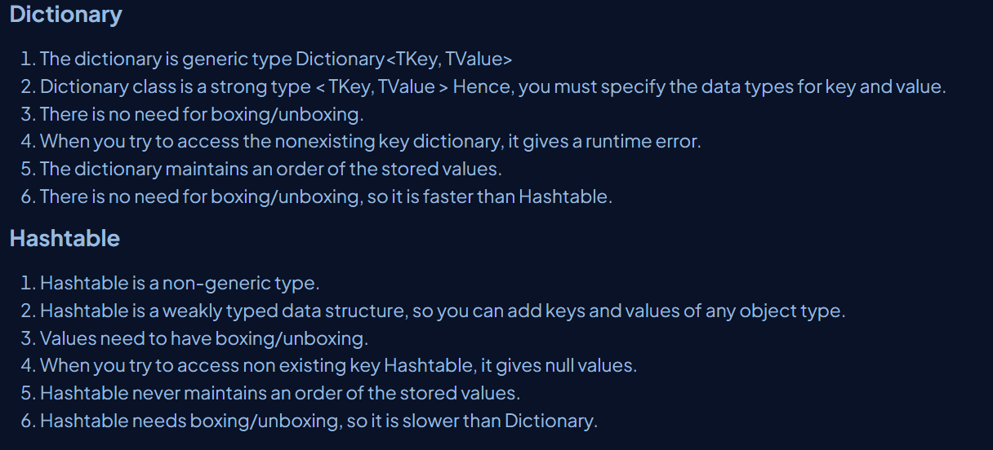

**base keyword in C#**

The base keyword is used to access members of the base class from within a derived class.

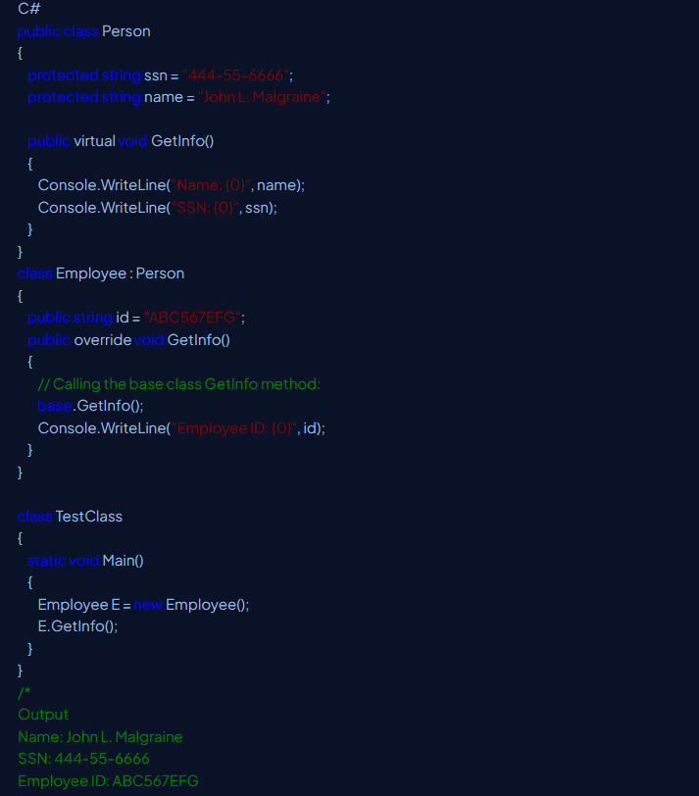

**How to handle Concurrency in Entity Framework core?**

Entity Framework Core primarily handles concurrency through concurrency control, which detects if data has been modified by another user or process since it was last read. This is achieved using concurrency tokens.



